## **Google-Chrome**

## **Pre-requisites:**

* Open Google Chrome.
* Browse url https://chromeenterprise.google/browser/download//#windows-tab.
* Select Stable, file type – msi and architechture – 64bit Click on ‘Download’ button. or
* You can Directly download the chrome by hitting below usrl.
* https://dl.google.com/tag/s/appguid%3D%7B8A69D345-D564-463C-AFF1-A69D9E530F96%7D%26iid%3D%7B2FBF3E19-ADFB-532D-E9EF-F952CC447775%7D%26lang%3Den%26browser%3D4%26usagestats%3D1%26appname%3DGoogle%2520Chrome%26needsadmin%3Dtrue%26ap%3Dx64-stable-statsdef_0%26brand%3DGCEA/dl/chrome/install/googlechromestandaloneenterprise64.msi

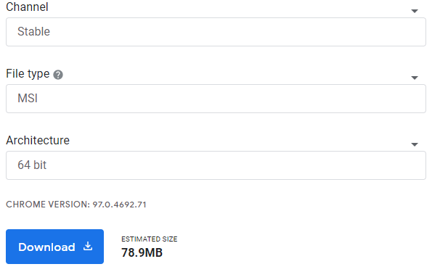

## **Installation:**

* Go to the location where the 'googlechromestandaloneenterprise64.msi’ file was downloaded.
* Run as an administrator.
* Double click on ‘googlechromestandaloneenterprise64.msi’.
* Wait for installation.
* Now Google-Chrome has been successfully installed.

## **Verification:**

* Open 'Control Panel'.
* Navigate to 'Programs\Programs and Features'.
* 'Chrome' and ‘Google chrome’ must be present in the installed software list.

